Architecture Development Part 4: Installation and Configuration of Hapi-FHIR Server

- Take a screenshot of the HAPI-FHIR server’s default web UI and submit it with your other lab materials. (5 points)
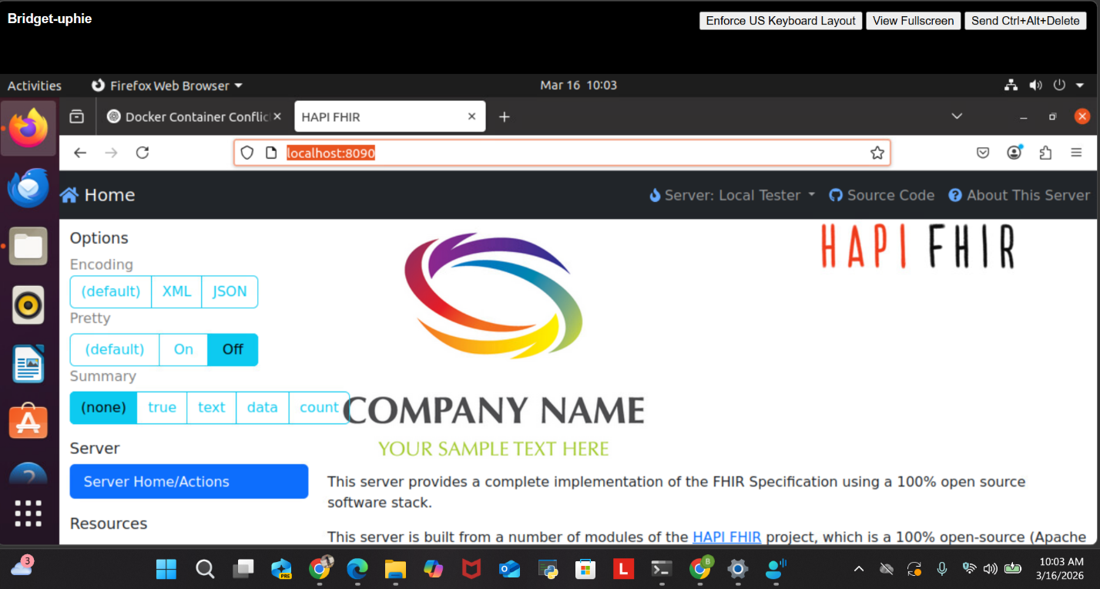

- What command could you use to check the total, used, and free memory in system if you thought the HAPI-FHIR server was not running properly due to lack of memory? (5 points)
To check for memory both total, used and free memory you use sudo free -h and after entering this command, I got the output as shown in the screenshot below.

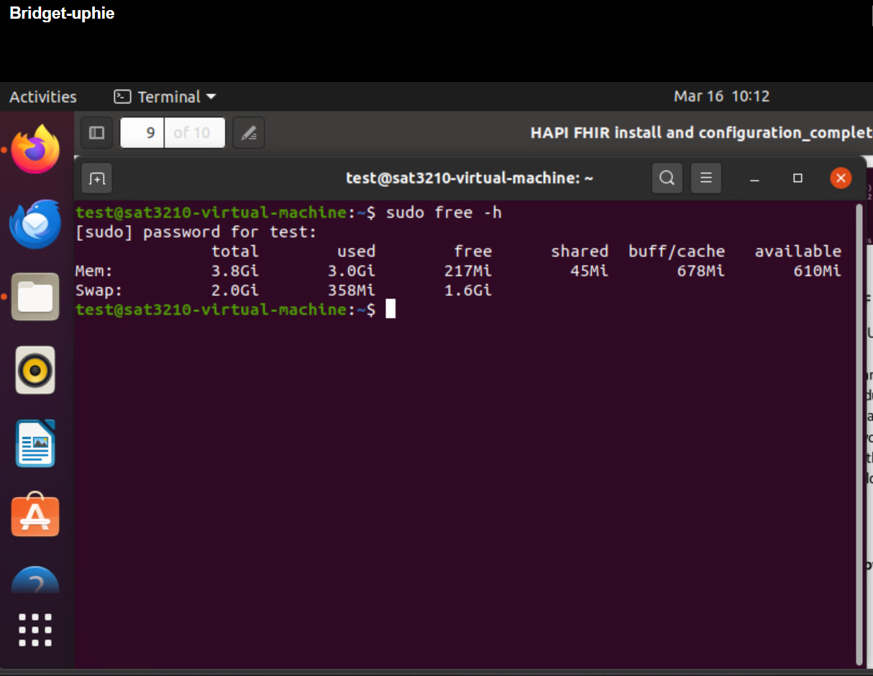

- You've updated the firewall rules on your Ubuntu server and want to check if the port (say 8080) used by the HAPI-FHIR server is open. What command would you use? (5 points)
The command I used sudo ss -tulnp | grep ':8090' see below screenshoot for the output and details after running the command
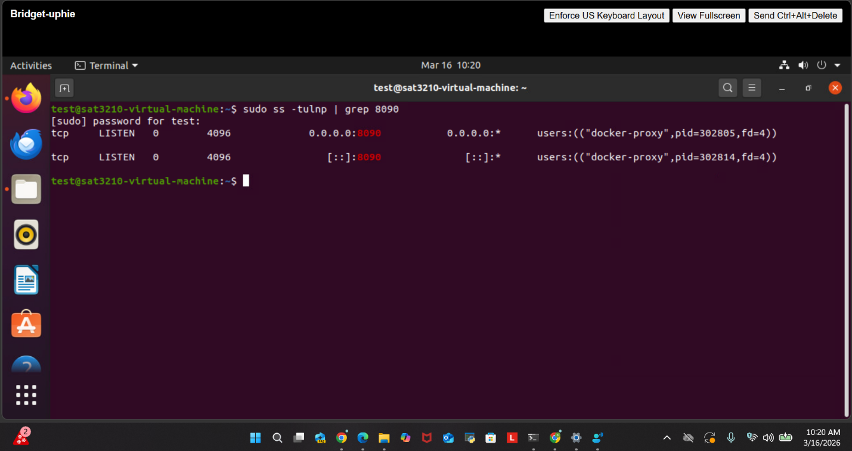

- If the HAPI-FHIR server fails to start, you want to ensure that there are no other processes occupying the default port (8080). What command should you use to check if the port 8080 is currently in use?
I used sudo lsof -i :8090 see below screenshoot for the output and details after running the command
